Linear Programming Exercises – Graphical Solution

- Product Mix Problem: Apex produces We produce two products: A fuel additive and a solvent base. Three raw materials are required for each product.
- 1 Kg of fuel additive requires 1 Kg of material1, 2 Kg of material2 and 1 Kg of material 3. While 1 Kg of the solvent base requires 0, 3 and 1 Kg respectively.
There are 6 Kg of material1, 19 Kg of material2 and 8 Kg of material3. Also the profit contributions are Rs5/Kg on Product 1 and Rs7/Kg on Product 2. The company wants to maximize their profit. Solve the problem graphically.

SOLUTION

- LP Formulation
Max z = 5x₁ + 7x₂
s.t.
x₁ < 6
2x₁ + 3x₂ < 19
x₁ + x₂ < 8
x₁, x₂ > 0

- The Feasible Space
x₂

8

7

6

5

4

3

2

1

1 2 3 4 5 6 7 8 9 10
x₁ + x₂ < 8

x₁ < 6

2x₁ + 3x₂ < 19

x₁

- The Optimal Solution: (5, 3)

Extreme Point | (0, 0) | (6, 0) | (6, 2) | (5, 3) | (0, 19/3)
Z | 0 | 30 | 44 | 46 | 44.33

- Optimum Objective Value: 46

- Solve the following Linear Programming Problem by answering the parts given below.

Min 5x + 6y
Subject to
3x + 1y ≥ 15
1x + 2y ≥ 12
3x + 2y ≥ 24
x, y > 0
  - Draw the feasible space
  - Identify the optimum solution
  - Compute the optimum objective value

- The Feasible Space
y

15

12

6

5 8 12

(2, 9)

(6, 3)

x

- The Optimal Solution: (5, 3)

Extreme Point | (0, 15) | (2, 9) | (6, 3) | (12, 0)
Z | 90 | 64 | 48 | 60

- Optimum Objective Value: 48

- Solve the following Linear Programming Problem by answering the parts given below.
Min 5x₁ + 2x₂
s.t.
2x₁ + 5x₂ > 10
4x₁ - x₂ > 12
x₁ + x₂ > 4
x₁, x₂ > 0

- Draw the feasible space
- Identify the optimum solution
- Compute the optimum objective value

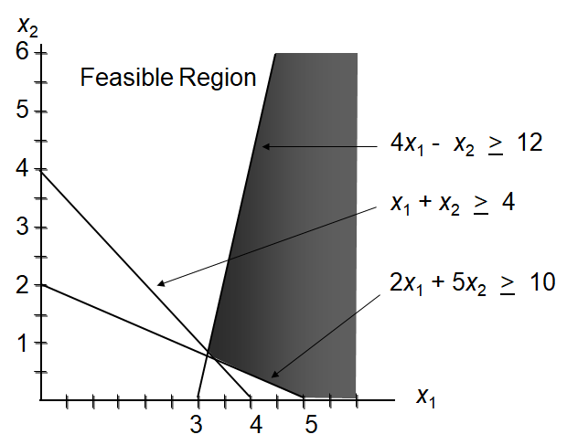
- The Optimal Solution: (16/5, 4/5)

Extreme Point | (16/5, 4/5) | (10/3, 2/3) | (5, 0)
Z | 17.6 | 18 | 25

- Optimum Objective Value: 17.6

